**E-commerce Project**

Project consist of E-commerce website datasets Which was collected from different souses like Kaggle, different E-commerce websites, different managers, senior person of our internship team those data I have to collected in CSV type files.

**Aim- to complete this project**

Despite the huge usage of ecommerce website, a section of the society still prefers offline stores. Why?

I am analysis still we have lots of souses of E-commers websites present in market big brands like Amazona, Flipkart, Mesho etc. there are stills peoples are buying products from store why?

**Objectives-**

- To analyze the usage of ecommerce website.

- To provide suggestions for improving the business on basis of Findings.

That’s the aim and object of my project. These full fills my requirement that’s why I collected data from October 2020 to February 2021. 5 months of data I have collected

In this project I used some tolls like Excel, MySQL

In analysis projects we have some steps involve like

* Data Collection
* Data Cleaning
* Data Exploration and Analysis
* Interpreted the results

Now see we have been completed first step is Data Collection, now our second step is Data Cleaning

Generally, as per our requirement we clean those row data. In this project I used Excel tools for Data Cleaning

In Excel – We use billing data, cleaning data, In Pivot table we are using summaries table, filtering table in various groups then after use some charts, bars, validation, make interactive dashboard for better understanding the clints

In these data was in UTC form we change into IST

UTC-Universal Time Coordinated

IST – Indian Time Standard

1)Using formula =B2+Time (5,30,0)

2)Then Change Date format dd/mm/yyyy to YYYY/MM/DD

Using format cell change the date format

3) In our data their is two columns are like Category_code and Brand having some blank rows are seen then using replace value function these function use to replace blank with NULL

Shortcuts in Excel is- CTRL + H

Then Save theses file in CSV (comma- separated-value) type

In SQL we create databases live Eventss;

CREATE TABLE evenness’s (

event_date date,

event_time varchar(500),

event_time_UTC varchar(500),

IST Text,

event_type Text,

Product_id integer,

category_id varchar(500),

category_code Text,

brand Text,

price float,

user_id varchar(500),

user_session Text

);

After creating table. I have collected large set of data that data inserted into table that’s why

using CMD (command prompt) insert all data into my table

Then Analise those query as per my requirement

**1**. Month of Sales

**2**.Top Time of Visit

**3**.Top brands by Sale

**4**.Demand for Items

**5**.Frequency of Purchase  
**6**.Actual Time purchased

**1**. Month of Sales

select event_date, sum(price) As Total_price ,

dense_rank() over (order by sum(price) desc) As Highest_value

from eventss

group by month(event_date),year(event_date)

order by event_date desc;

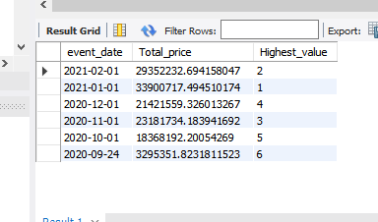

**2**.Top Time of Visit

Select hour(event_time) as Hour_UTC,count(event_date) as Number_of_times

from eventss

Where event_type ='view' or event_type ='cart'

Group by hour(event_time)

order by count(*) desc

limit 5;

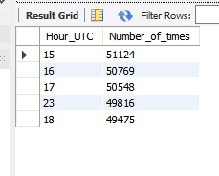

**3**.Top brands by Sale

select brand, sum(price),

dense_rank() over (order by sum(price) desc) as W_R_T_Top_brand

from eventss

where brand!='Null'

group by brand

limit 10;

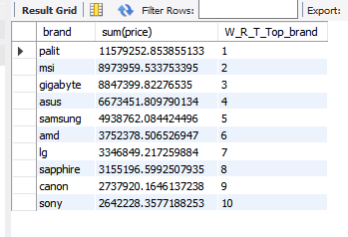

**4**.Demand for Items

select category_code, count(category_code),

dense_rank() over (order by count(category_code)) as "Top_category"

from eventsss

where category_code!='Null'

group by category_code

limit 7;

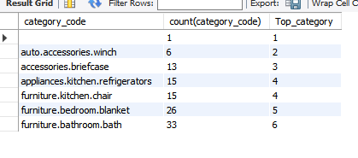

**5**.Frequency of Purchase

Select hour(event_time) as Hour_UTC,count(event_date) as Number_of_times

from eventss

Where event_type ='purchase'

Group by hour(event_time)

order by count(*) desc limit 5;

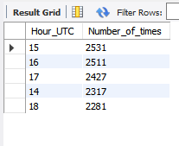

**6**.Actual Time purchased

select * from

(

select product_id, count(*) as time_viewed, event_type from eventsss

where event_type='purchase'

group by product_id

) as a

inner join

(

select product_id, count(*) as times_purchased, event_type,category_code,brand from eventsss

where event_type='view'

group by product_id

) as b

on a.product_id=b.product_id

order by time_viewed and times_purchased asc;

